nigelchopping@googlemail.com
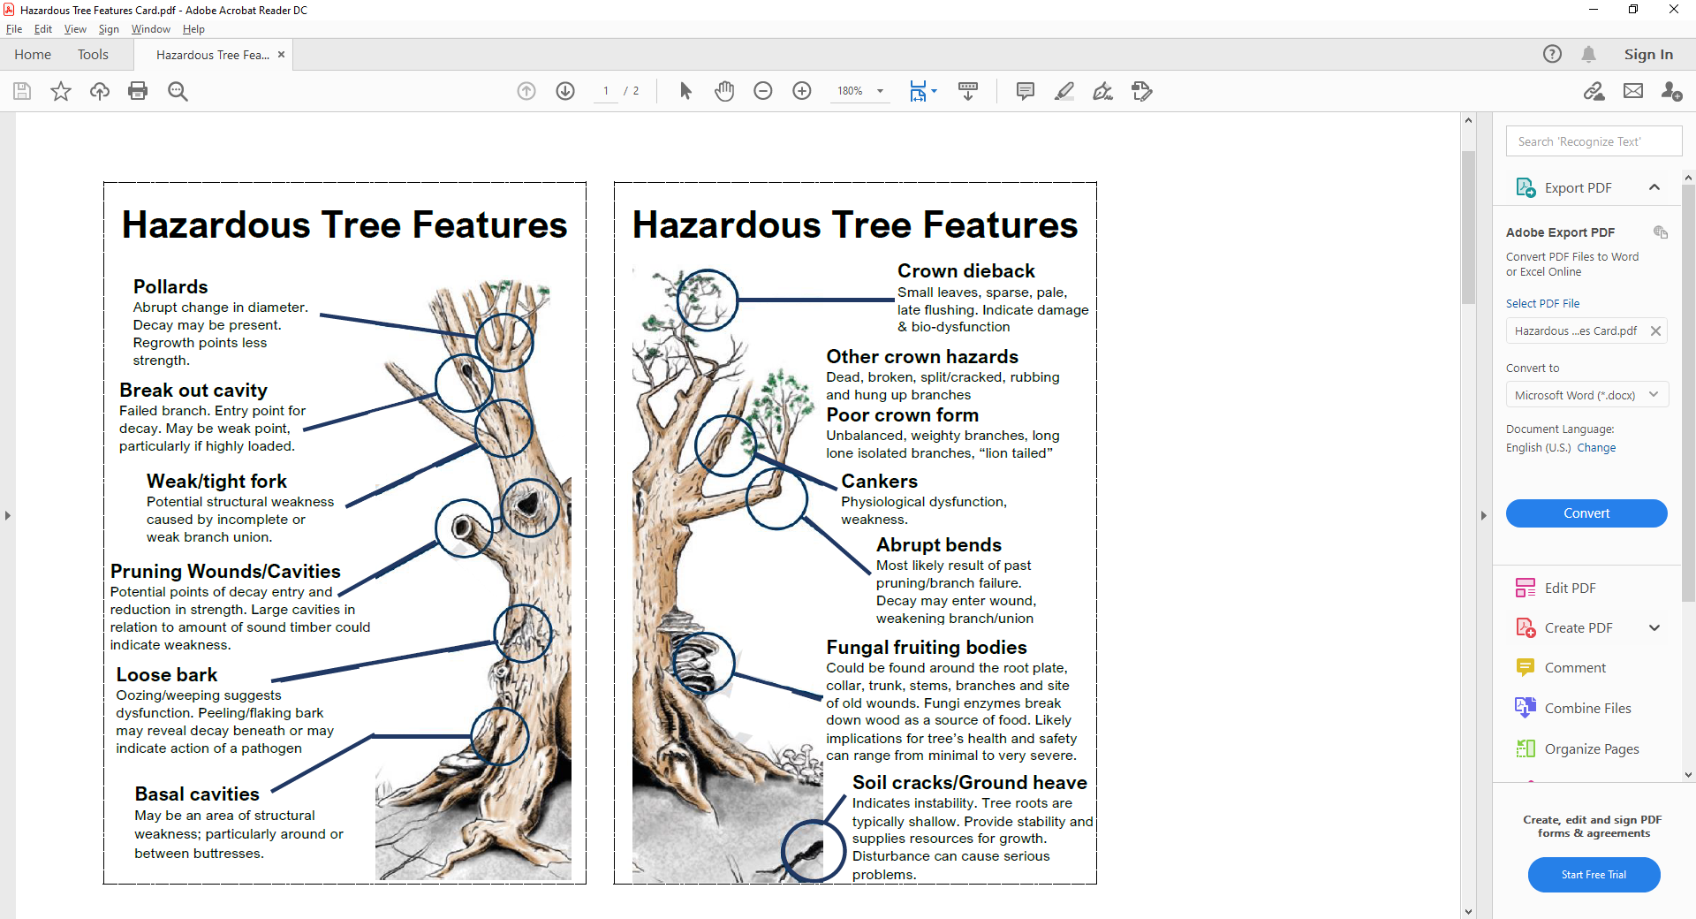
nigelchopping@googlemail.com

